List Views

You can use one of django’s built in list views.



Or you can also edit these views with your own defs:

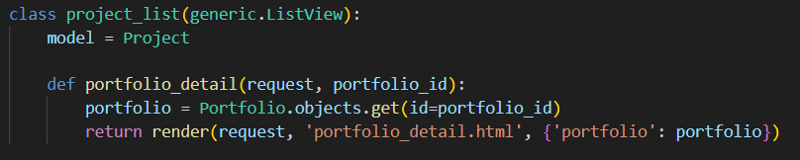

The above example allows you to add functionality to grab only the projects linked with that portfolio.

Similarly on our Home Page, we use the following def to query the active portfolios to list. While not like the previous list view, we can still iterate through this with a for loop.

